Dishwasher System Analysis

# Use Case Diagram – Dishwasher

Diagram 1: Use Case Diagram

The use case diagram models the interaction between the User and the Dishwasher system, focusing on the main scenarios involved in operating a dishwasher. It shows external behavior from the user's perspective.  
  
Actors:  
- User: Operates the dishwasher—loads dishes, selects programs, starts or pauses cycles, monitors progress, and unloads dishes.  
- System: Includes any required external services (water, power, maintenance).  
  
Use Cases:  
- Load Dishes: User puts dirty dishes in the machine.  
- Add Detergent: User adds detergent before starting the wash.  
- Select Program: User selects wash cycle (Normal, Eco, Intensive, etc.).  
- Start/Pause Cycle: User starts or pauses the operation.  
- Monitor Progress: User can see the current state of the cycle.  
- Receive Alerts: System notifies user about errors or states (e.g., water supply low).  
- Unload Dishes: User removes clean dishes at the end.

# Block Definition Diagram (BDD) – Top Level

Diagram 2: BDD – Dishwasher Structure

The Block Definition Diagram (BDD) shows the structural decomposition of the dishwasher system, with the main blocks and their roles.  
  
Main Block:  
- Dishwasher: Top-level system.  
  
Sub-Blocks:  
- Heating Unit: Heats the water.  
- Spray Arm: Distributes water inside.  
- Controller: Manages cycles and operations.  
- Detergent Dispenser: Dispenses cleaning agent.  
- Drain System: Removes waste water.

# Activity Diagram – Black Box Scenario

Diagram 3: Activity Diagram – Black Box

Shows the dishwasher’s operational flow from start to finish as a “black box”.  
  
Inputs:  
- Dirty Dishes  
- Water  
- Detergent  
- Electrical Power  
  
Flow:  
1. Load Dishes: Place dirty dishes in the washer.  
2. Add Detergent: Add detergent.  
3. Wash Dishes: Clean with water and detergent. Output: Waste Water  
4. Dry Dishes: Uses power to dry. Output: Steam  
5. End Cycle. Output: Clean Dishes

# 4. Block Definition Diagram – Input/Output Definitions

Shows how the dishwasher is structurally decomposed into subsystems and their relationships, focusing on key interfaces and flows.

Diagram 4: BDD – Input/Output

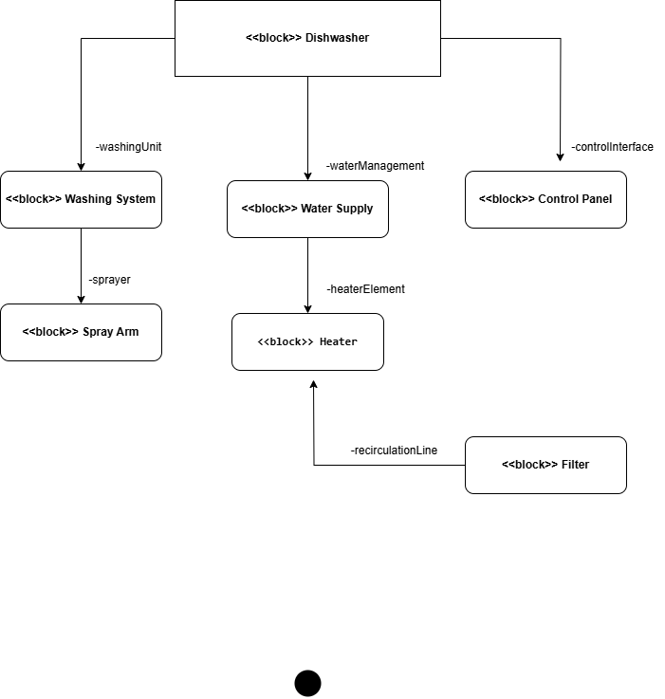

# 5. Block Definition Diagram – Dishwasher Hierarchy

Shows the main system and subsystems, highlighting the architectural hierarchy.  
  
- Dishwasher  
 - Control Panel  
 - Washing System (with Spray Arm, Filter)  
 - Water Supply  
 - Heater

Diagram 5: Dishwasher Hierarchy

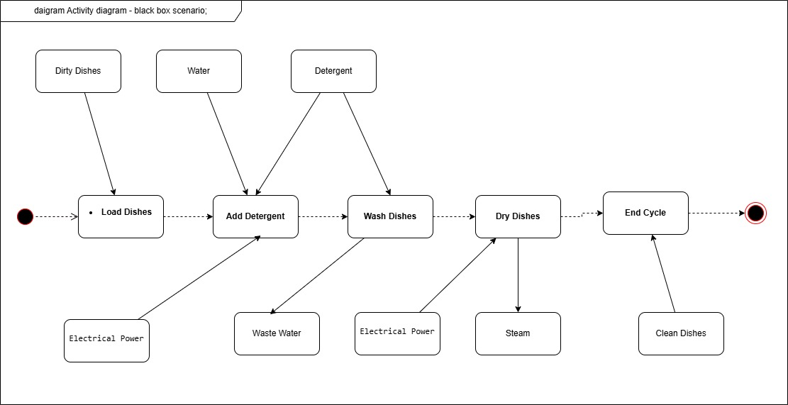

# 6. Activity Diagram – White Box Scenario

Shows the internal operational workflow in sequence:  
1. Load Dishes  
2. Add Detergent  
3. Wash Dishes  
4. Drain Water  
5. Dry Dishes

Diagram 6: Activity Diagram – White Box

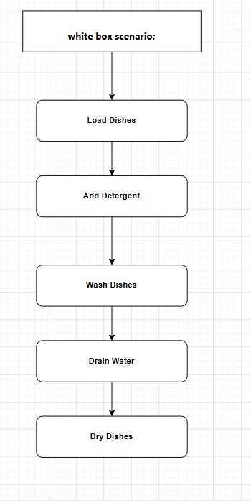

# 7. State Machine Diagram – Dishwasher States

Illustrates the main operational states and transitions:  
Idle → Filling Water → Washing → Rinsing → Drying → Idle

Diagram 7: State Machine Diagram

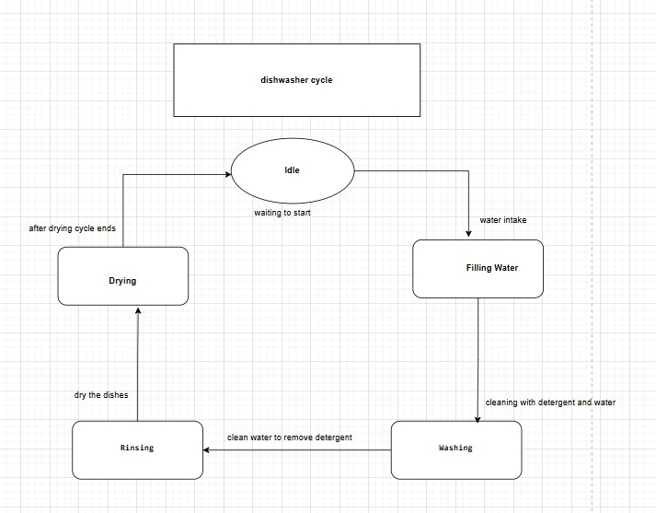

# 8. Sequence Diagram – Interactions Between Dishwasher Parts

Shows the time-based sequence of actions between components:  
- Dishwasher  
- Washing System  
- Detergent Dispenser  
- Control Panel

Diagram 8: Sequence Diagram

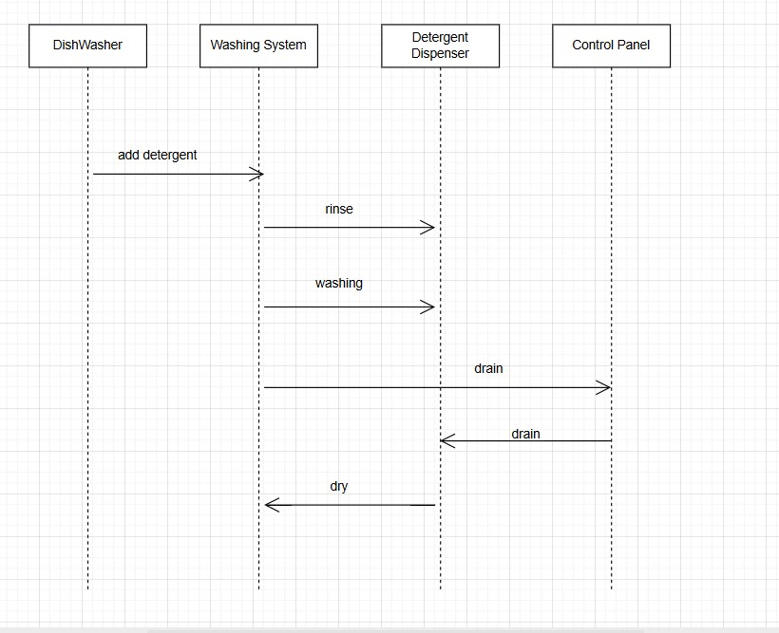

# Explanations of Diagrams

Block Definition Diagram (BDD):  
Shows main system structure, blocks, and responsibilities. Helps understand which part does what.  
  
Activity Diagrams:  
- Black Box: Focus on input/output and overall process.  
- White Box: Step-by-step flow inside the system.  
  
State Machine Diagram:  
Displays main states and how dishwasher progresses through its operation.  
  
Sequence Diagram:  
Demonstrates interaction and message flow between components in real time.